Project Structure

Step 1: what our portfolio is like
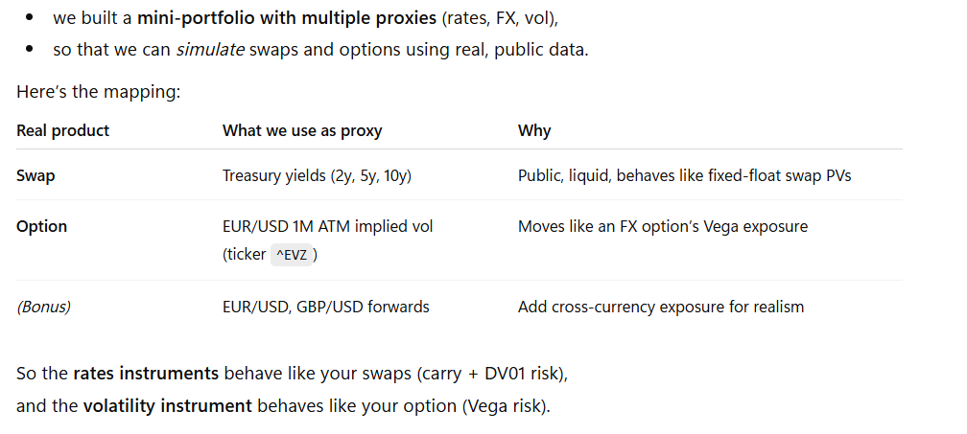

Step 2: where risk and return are calculated
- Load weekly returns :
--> Each column is one asset on the csv file
- Estimate the expected return(µ):
- use the last week return (carry)
- this is the expected payoff from each asset.
- Estimate Risk:
- Compute covariance for mean-variance optimizer
- Optimization:
- Solves for weights w(how much of each asset to hold)
- Objective (mean-CVaR):
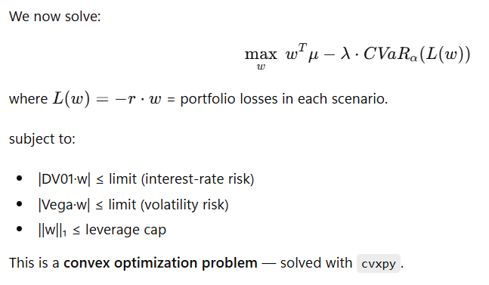
- Apply weights, simulate next-week PnL; store return, and repeat

Step 3: Where risk metrics come from
